**Một số nội dung quan trọng tại Kết luận số 127-KL/TW của Bộ Chính trị, Ban Bí thư**[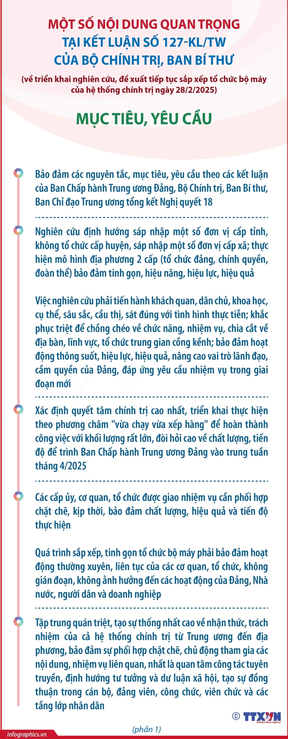](https://xdcs.cdnchinhphu.vn/446259493575335936/2025/3/1/11-1740838603817139576979.jpg)

[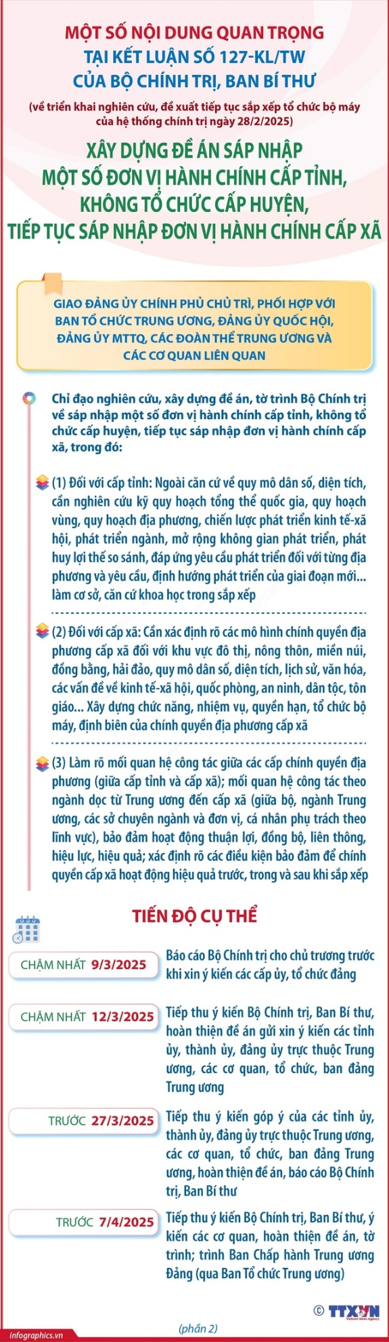](https://xdcs.cdnchinhphu.vn/446259493575335936/2025/3/1/2-17408386179261709530243.jpg)

[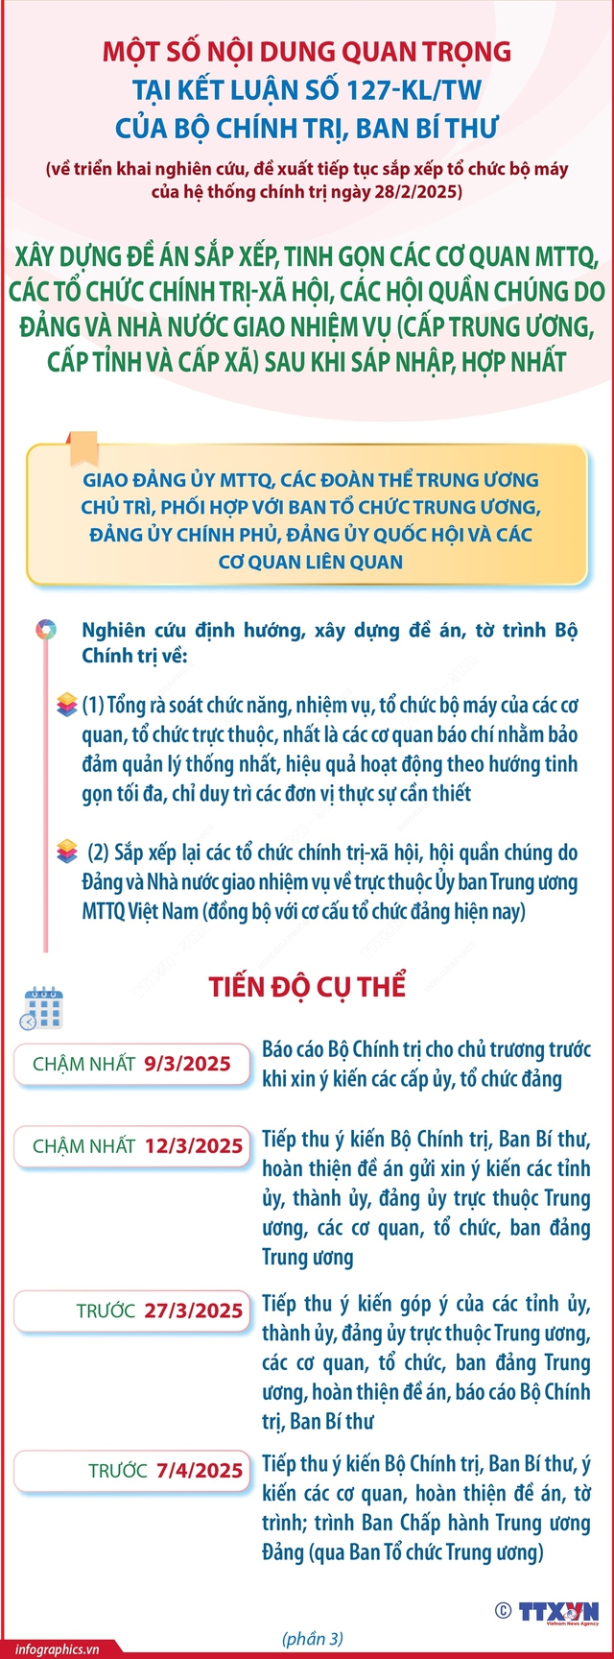](https://xdcs.cdnchinhphu.vn/446259493575335936/2025/3/1/3-1740838630351492872115.jpg)

[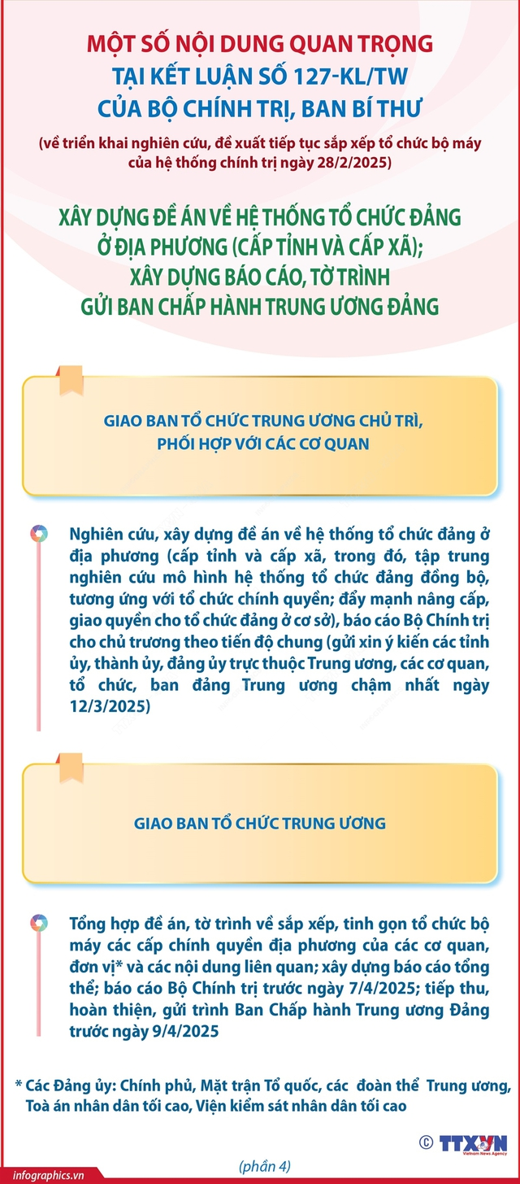](https://xdcs.cdnchinhphu.vn/446259493575335936/2025/3/1/4-17408386426351649001042.jpg)

[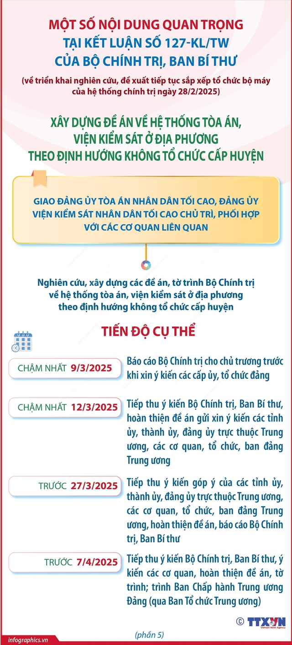](https://xdcs.cdnchinhphu.vn/446259493575335936/2025/3/1/5-17408386538762123325993.jpg)

[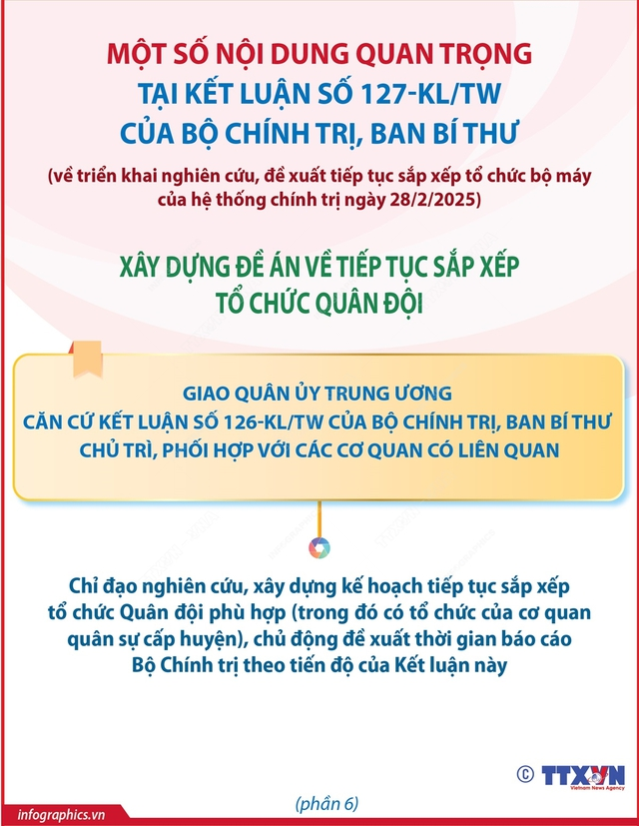](https://xdcs.cdnchinhphu.vn/446259493575335936/2025/3/1/6-17408386655111072374390.jpg)

[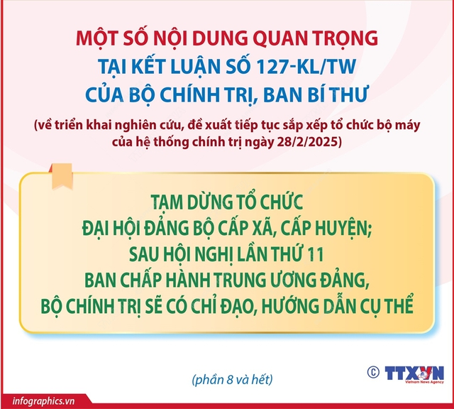](https://xdcs.cdnchinhphu.vn/446259493575335936/2025/3/1/7-17408386823181863698854.jpg)

Theo TTXVN